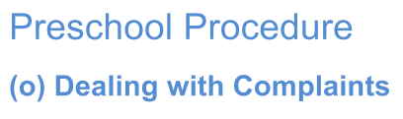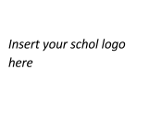

Current | February 2018
Next Review | February 2019
Regulation(s) | R. 173
National Quality Standard(s) | 7.3.4 Processes are in place to ensure that all grievances and complaints are addressed, investigated fairly and documented in a timely manner.
Relevant DoE Policy and link | Complaints Handling Policy PD/2002/0051/V04 https://www.det.nsw.edu.au/policies/general_man/complaints/resp_sugg/PD20020051. shtml  Complaints Handling Policy Guidelines (2011) https://www.det.nsw.edu.au/policies/general_man/complaints/resp_sugg/April2011_Co mplaints%20Handling%20Policy%20guidelines.pdf
Key Resources | Policy for Protecting Children and Young People, 2010  Responding to Allegations against Employees in the Area of Child Protection, 2009

- Our preschool values the feedback of educators, staff, families and the wider community in helping to create a service that meets regulation and the needs of enrolled children and their families.

- We encourage open communication through opportunities to respond and feedback on the program. A component of this feedback is the ability to put forward a complaint and have this managed appropriately with due consideration for accountability and quality improvement.

- All minor complaint and disputes will be resolved promptly and without using formal procedures. Whenever possible, informal resolution will be attempted first in all matters assessed as less serious.

- Families are advised to initially make complaints to our teachers or principal, whoever is most appropriate, by appointment. Complaints will be dealt with confidentially and professionally, as per the NSW Education and Communities Complaints Handling Policy, 2011.

- Displayed in the preschool entrance (on the DoE template), is the photo and name of the school principal and a statement noting this is the person a complaint can be made to.

- Also displayed in the entrance is a statement advising families that if their complaint is of a more serious nature, or relates to the breach of a regulation, they may choose to contact our regulator;

NSW Early Childhood Education Directorate,
Department of Education
e-mail: ececd@det.nsw.edu.au phone: 1800 619 113

- Complaints of a child protection nature should be referred promptly to the principal or Department of Family Services.

- If a staff member has concerns related to the behaviour or actions of another employee, contractor or volunteer, they should contact the Director, Employee Performance and Conduct Directorate (EPAC), or an EPAC Investigator, on telephone (02) 9266 8070.

- Information about the Department of Education Complaints procedure can be found at the end of the parent handbook.

- Records of complaints are kept in a locked filing in the principal’s office.

